# CS 255 Business Requirements Document Template

Complete this template by replacing the bracketed text with the relevant information.

This template lays out all the different sections that you need to complete for Project One. Each section has guiding questions to prompt your thinking. These questions are meant to guide your initial responses to each area. You are encouraged to go beyond these questions using what you have learned in your readings. You will need to continually reference the interview transcript as you work to make sure that you are addressing your client’s needs. There is no required length for the final document. Instead, the goal is to complete each section based on your client’s needs.

**Tip:** You should respond in a bulleted list for each section. This will make your thoughts easier to reference when you move into the design phase for Project Two. One starter bullet has been provided for you in each section, but you will need to add more.

## System Components and Design

### Purpose

*What is the purpose of this project? Who is the client and what do they want their system to be able to do?*

* **Client:** DriverPass, a company that wants to lend a helping hand to those struggling on passing their driver’s test.
* **System Purpose:** DriverPass would like to offer their customers the availability to participate in online classes as well as take practice tests. On the road training will also be available if the user would like that as well.

### System Background

*What does DriverPass want the system to do? What is the problem they want to fix? What are the different components needed for this system?*

* **Problem:** Liam, the owner of DriverPass, noticed that there needs to be better training available for new and up-coming drivers since so many are failing tests at the DMV.
* **Solution:** Have a system that can be accessed both online and offline. While offline, it can view the data stored in the system. While online, user should be able to use services provided from system. If any data was changed on the system offline, then online access should update the information where applicable.
* **System:** Provide the user the ability to reserve and partake in online classes, practice tests, and even on-the-road driving training if the user would prefer.

### Objectives and Goals

*What should this system be able to do when it is completed? What measurable tasks need to be included in the system design to achieve this?*

* **End-User Based Objectives:**
  + Take online classes, practice tests, and on-the-road driving training if user would like.
  + Create account after providing necessary information: First and last name, phone number, address, state, credit card number, expiration date, and the security code of the card.
  + Classes are two hours long, if customer has more than 2 hours schedules, then it will need to be broken up over multiple sessions; date and time of classes need to be recorded
  + Classes can be reserved either through an online account or through phone call with three options available at the time:
    - Package #1: Six hours in car with trainer
    - Package #2: Eight hours in a car with a trainer and an in-person lesson explaining the rules and policies of the DMV
    - Package #3: Twelve hours in a car with a trainer, explanation of the DMV rules and policies, as well as access to the online classes with all content and material unlocked. Access to the online tests should also be granted with this package
  + Should password be forgotten, an option to reset the password should be available.
  + Ability to check progress of online tests which will display in one of four settings: Passed, In Progress, Failed, or Not Taken
* **Product Owner Based Objectives:**
  + While offline, be able to view last saved uploaded data. While online, be able to update current data, download reports and information that could be worked on later at home.
  + Need to be able to track which user is matched with which driver, the time the user requested to take the lesson, as well as the car that will be used
  + Be able to customize the packages in the future, so the system should be flexible
  + Should be able to disable packages so that if the owner doesn’t want more customers to register for it.
  + Has provided a layout of how the interface for the system should look (See image below)

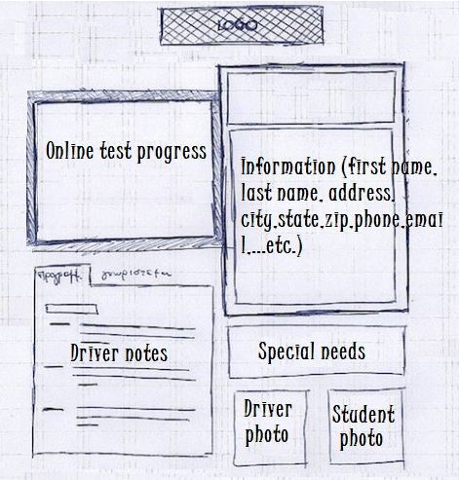

* + Would like to see any comments left by drivers as well as the time for their lesson in a table like this:

|  |  |  |  |
| --- | --- | --- | --- |
| **Lesson Time** | **Start Hour** | **End Hour** | **Driver Comments** |
|  |  |  |  |
|  |  |  |  |

* + Input form where student (or secretary) can input student information such as: first name. last name, address, et cetera.
* **IT Officer Based Objectives:**
  + Needs to have complete access over all of the accounts. This is so that any users that are “let go” can be blocked from accessing their account.
  + Ensure that the password forget function is included for the user to be able to accomplish. *No IT support should be needed to complete this task*
  + System should run online on the web, preferably the cloud to run the business with minimal technical problems.

## Requirements

### Nonfunctional Requirements

*In this section, you will detail the different nonfunctional requirements for the DriverPass system. You will need to think about the different things that the system needs to function properly.*

#### Performance Requirements

*What environments (web-based, application, etc.) does this system need to run in? How fast should the system run? How often should the system be updated?*

* The client wants the environment of the system to be web-based and able to exist within the cloud. This is probably due to the cloud being able to store data such as the tests and lessons for the user to request from their own device.
* System should be able to viewed offline as well as online. However, while the system is being viewed offline no information can be changed or updated until the system is online again. This is to prevent data redundancy in the system.

#### Platform Constraints

*What platforms (Windows, Unix, etc.) should the system run on? Does the back end require any tools, such as a database, to support this application?*

* Client made no remarks about platform specificity. Assume that the client wants the system to be accessed by Windows, MacOS, Linux, iOS, and Android devices.
* Clients would like for the system to have access to the DMV database to view content such as tests and practice tests that can be accessed from the DMV’s database. The information that is on the client’s system should be current with the information found on the DMV’s website.

#### Accuracy and Precision

*How will you distinguish between different users?* *Is the input case-sensitive? When should the system inform the admin of a problem?*

* I believe that the best way to distinguish the users of the system is be establishing role-based access control. The role of the user can be authenticated through the username and password.
* High accuracy and precision is the goal of most if not all programs and systems, this one is no exception.

#### Adaptability

*Can you make changes to the user (add/remove/modify) without changing code? How will the system adapt to platform updates? What type of access does the IT admin need?*

* By the sounds of the interview, it would appear that the IT admin is requesting complete control of the system. This is so that the IT admin can help reset passwords for the customer and block access of employees that were let go.
* There are hopes and plans for the system to be able to allow for more/less packages that are offered to the customer. However, it is specified by the owner that we are to focus on the current desired features before we start looking to far in the future.

#### Security

*What is required for the user to log in? How can you secure the connection or the data exchange between the client and the server? What should happen to the account if there is a “brute force” hacking attempt? What happens if the user forgets their password?*

* In order to create an account, a user will need to provide:
  + First and Last Name
  + Address
  + Phone Number
  + State of Residence
  + Credit Card Information (16-digits, Exp. Date, security code)
* After the account has been made, the only information that should be needed to login is the authorized username and password that belong to the appropriate user.
* Should the user forget their password to their account, the system should provide the user the ability to reset their password without the need of IT assistance. (i.e., “Forgot Password?” Hyperlink)
* Although there was no discussion of “brute force” hacking, any account that should be compromised through this tactic will be blocked of any and all access to the system. This is to not only isolate the threat, but to safeguard the system.

### Functional Requirements

*Using the information from the scenario, think about the different functions the system needs to provide. Each of your bullets should start with “The system shall . . .” For example, one functional requirement might be, “The system shall validate user credentials when logging in.”*

* The system shall display up-to-date information provided from the DMV database
* The system shall verify the authorization of the user through means of authentication
* The system shall allow the user to reset their password, without IT assistance, if needed
* The system shall store user information in a safe, and secure manner
* The system shall run on a cloud-based server to access online content/information
* The system shall have the ability to run offline, only for viewing purposes
* The system will have connection to DMV servers to ensure information on system is up-to-date with DMV server information
* The system shall have a display for the customer that is easy to use and navigate
* The system shall be able to be customizable for future features, updates, and packages
* The system shall be able to run on all major operating systems and mobile device, to allow for a larger and diverse audience base
* The system shall have Role-Based Access Control (RBAC) to distinguish responsibilities and authority to the users respectively
* The system shall have a notification system for the admin in case any of the customers or secretary make an adjustment to an appointment

### User Interface

*What are the needs of the interface? Who are the different users for this interface? What will each user need to be able to do through the interface? How will the user interact with the interface (mobile, browser, etc.)?*

* **Users for Interface:**
  + Admin “Big Boss”
    - Edit System Information
    - Customize Packages for Customers
    - Close Packages that are overbooked
    - Download report of system to be able to work on personal machine
    - Receive notifications if any appointment changes are made
  + IT Admin
    - Ability to reset password for employees and customers
    - Ability to restrict access of users in the event an employee is “let go”
  + Customer
    - Ability to make, change, or cancel appointments
    - Ability to view practice tests and lessons offered on system
    - Ability to view driving learning progress
    - Ability to request in-person driving lessons offered by system
  + Secretary
    - Ability to make, change, or cancel appointments

### Assumptions

*What things were not specifically addressed in your design above? What assumptions are you making in your design about the users or the technology they have?*

* Assume that the system will flag activity of user failing in about three times
  + Lock account and recommend resetting password, notify Admin and IT Admin
* Assume system can perform if machine has low-bandwidth or poor service
* Assume that cloud-based service will be determined by product owner
* Assume Secretary has similar responsibilities and authorities of Admin and Customer
* Assume security measures, such as algorithm ciphers, are being worked on by the security team

### Limitations

*Any system you build will naturally have limitations. What limitations do you see in your system design? What limitations do you have as far as resources, time, budget, or technology?*

* Internet connection is required for full service of system
* No clarification of budget, assume cheapest method possible
* Time constraint of almost 16 weeks for full launch.
* Assume company has either Windows or MacOS machines, Linux would be not likely due to skill of use required

### Gantt Chart

*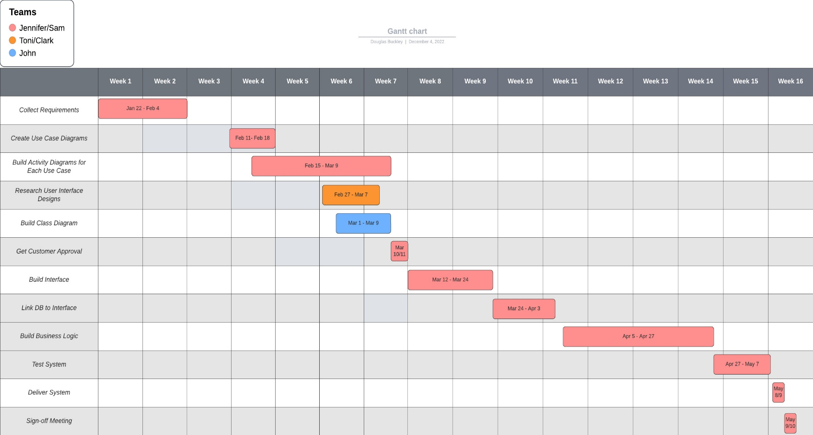Please include a screenshot of the GANTT chart that you created with Lucidchart. Be sure to check that it meets the plan described by the characters in the interview.*